SERVICE DELIVERY PLAN 2023-24:
October to December 2023

INDEX

Total emergency calls

Total incidents

Total fires

Primary fires

Secondary fires

Special services

False alarms

Attendance standard

Sickness absence

Carbon output

Objective:

Good performance is reflected on the top bar of each indicator graph. We use Red, Amber, and Green to indicate how each indicator is performing. Amber reflects an indicator is within 10% of target.

BENCHMARK INDICATORS
TC00 Total number of emergency calls received
Service Plan Target | No target - Quality Assurance |  | Progress to Date |  |  | 15991
Cumulative Performance
TO00 Total number of emergency calls received  DO22 The % of 999 calls answered within 10 seconds |  |  | For quality assurance only
TC00 | By 31st December 2023 Fire Control had received 15991 emergency calls. This was 4299 fewer calls than this time last year, when 20290 calls were received.  November (1631) saw a very similar number of calls to November 2022 (1694) reflecting another relatively quiet Bonfire period.  This indicator does not have a target it is monitored for quality assurance only.
DR22 | Cumulatively 97.9% of 999 calls were answered within 10 seconds. This performance achieves the 96% target.
TC01 The total number of incidents attended
Service Plan Target  Apr-Dec 2023 |  | 15149 |  | Progress to Date | 13614
Cumulative Performance
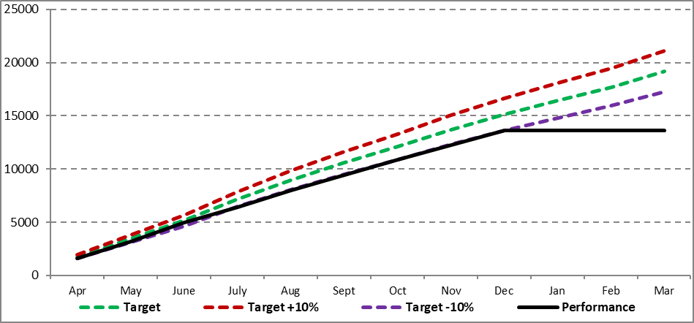
TC01 Total number of incidents attended

TC01 |  | Performance against all key performance indicators (KPI’s) has remained under target for this reporting period except false alarms and special service calls. We do not want to discourage or reduce some types of false alarm (Good Intent) and special services (e.g. assisting the ambulance service or Police).  During this period there have been 1238 fewer incidents attended (13614) than at this time last year (14852). The Bonfire period saw fewer incidents than in 2022, in November 2023 crews attended 1387 compared to 1404 in November 2022  The number of Special Service incidents attended (3968) are 170 than in previous years (4138 in the 3rd quarter of 2022-23). MFRS continues to assist partner agencies on a regular basis.

TC02 Total number of fires attended in Merseyside
Service Plan Target  Apr-Dec 2023 | 5850 | Progress to Date | 4433
Cumulative Performance
TC02 Total number of Fires attended in Merseyside

TC02 | Crews attended 4433 fires from April to December 2023. This is 1442 fewer than in 2022 (5875) and also 1417 below the cumulative target of 5850.  This reporting period, October to December saw 1082 fires. Numbers of fires have varied throughout the year from the peak in June which saw 750 fires while December saw 273.  Arson teams and high visibility patrols alongside our targeted prevention work continue to improve outcomes for the Service.

TC03 Total number of primary fires attended
Service Plan Target  Apr-Dec 2023 |  | 1497 |  | Progress to Date | 1268
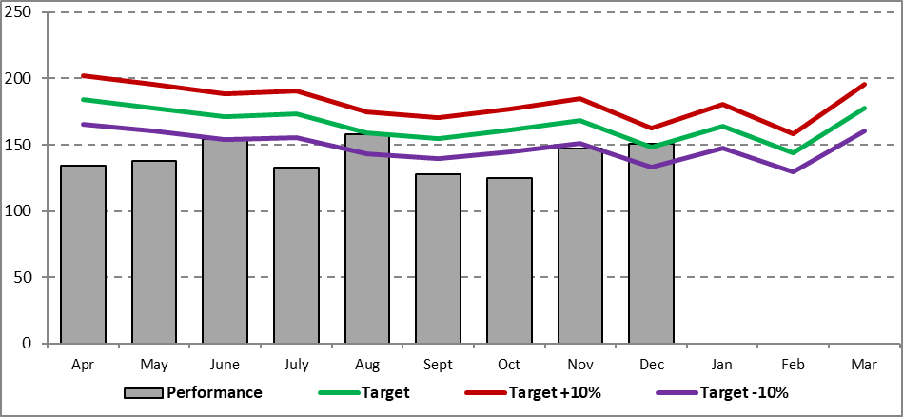
Cumulative Performance
TC03 Total number of primary fires attended

TC03 | During the period April to December 2023 crews attended 1268 Primary Fires. This is 181 fewer than in 2022/23 (1449).  The number of accidental dwelling fires attended remain lower than last year and below cumulative targets. Both types of deliberate dwelling fires are now within 10% of the cumulative target  Deliberate vehicle fires to date during 2023/24 (182) have also decreased when compared to 224 during quarter 3 of 2022/23. This is also 105 under the cumulative target.  n.b.Primary fires involve an insurable loss and includes all property related fires, or large scale secondary fires where 5 or more appliances are in attendance.

DC11 Number of accidental dwelling fires
DC12 Number of fatalities in accidental dwelling fires
DC13 Number of injuries in accidental dwelling fires
DC14 Number of deliberate dwelling fires in occupied properties
DC15 Number of deliberate dwelling fires in unoccupied properties
DC16 Number of deaths occurring in deliberate dwelling fires
DC17 Number of injuries occurring in deliberate dwelling fires

COMMENTARY:
DC11 | Accidental dwelling fires during 2023/24 at 507 are considerably lower than the cumulative target for quarter 3 (620). There have been 92 fewer incidents than at Q3 2022/23, when crews had attended 599 accidental dwelling fires. December saw a peak with 77 incidents, 13 of which were related to faulty appliances.
DC12 | There have sadly been 2 fatalities in accidental dwelling fires to date. The most recent in September is awaiting the coroner’s verdict as to cause of death.
DC13 | There have been 34 injuries in Accidental Dwelling Fires. This is below the cumulative target of 66.
DC14 | Deliberate dwelling fires in occupied property (98) is above the cumulative target (95) and exactly the same at this period in 2022/23. There were an unusually high number in November (17) but there was no identifiable pattern to these fires other than a number were in the Birkenhead area.
DC15 | Deliberate fires in unoccupied properties (13) is within 10% of the cumulative target (12) and the same as Q3 2022.
DC16 DC17 | There have been no fatalities but 7 injuries in deliberate dwelling fires to date.
DC11 Number of accidental fires in dwellings
Service Plan Target  Apr-Dec 2023 |  | 620 | Progress to Date | 507
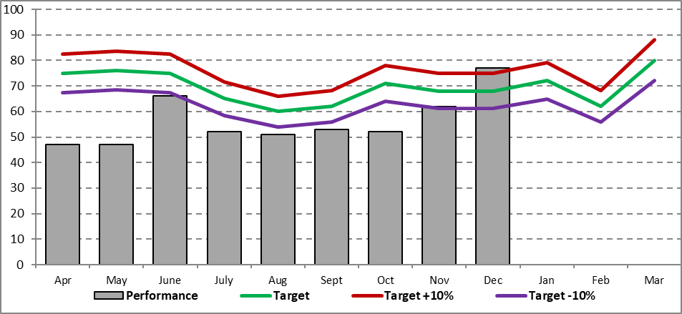

DC14 Number of deliberate dwelling fires in occupied properties
Service Plan Target  Apr-Dec 2023 | 95 | Progress to Date | 98
DC15 Number of deliberate fires in unoccupied properties
Service Plan Target  Apr-Dec 2023 | 12 | Progress to Date | 13

TC04 Total number of secondary fires attended
Service Plan Target  Apr-Dec 2023 | 4353 |  |  |  | Progress to Date |  | 3165
Cumulative Performance
TC04 Total number of secondary fires attended
AC13 Number of deliberate ASB fires attended
TC04 |  |  | There were 3165 secondary fires during this reporting period. This is 1261 fewer than in 2022/23 (4426). Following an increase in incidents during June (596) incident numbers have fallen and remained fairly stable until a further drop to 122 in December
AC13 |  |  | The count of anti-social behaviour fires (2014) is 757 less this year than in 2022/23 (2771) and achieves the cumulative Q3 target (2737). Incident numbers remained relatively consistent throughout the year with a slight peak in June (341) and no noticeable increase during the Bonfire period in November with 171 incidents. December saw just 71 of this type of fire.  The Arson Reduction Team continue to work with partner agencies on initiatives such as Operation Banger to reduce the number of bonfires and associated misbehaviour and injuries.
TC05 Total number of special services attended
Performance at Q3 22/23 |  | 4138 |  |  |  | Progress to Date |  | 3968
Cumulative Performance
TC05 Total number of Special Services attended |  |  |  |  |  | For quality assurance only
TC05 |  |  |  | When personnel and equipment are deployed for services other than firefighting, those services are referred to as a ‘Special Service Call’ (SSC) and may be either ’emergency’ or ‘non-emergency.’ Many are related to assisting partner agencies such as the Police and Ambulance, particularly related to providing medical assistance and effecting entry. They also include incident types like road traffic collisions and water rescue.  From April to December 2023 the number of special services attended (3968) was lower than in 2022 (4138) a decrease of 170 incidents. Assisting other agencies accounted for a quarter of all calls.  Special service calls attended are counted for quality assurance only as a number of incident types (particularly those where MFRS is assisting other agencies) are encouraged, rather than MFRS being in a position to take action to prevent them as is the case with most other emergency response activity.
RC11  RC12  RC13  RC16  RC24 |  |  |  | The number of road traffic collisions attended (607) is lower than last year (635). There is no target for this incident type.  Sadly there have been 9 fatalities in RTC’s attended by MFRS and 227 injuries (178 of which were slight injuries). This increase is also reflected in the Police data below.  Police RTC data relating to the 15-20 year old age group, which is the age group MFRS Prevention teams work with, shows that the number of incidents where a young person has been killed or seriously injured has increased from 39 in 202 to 54 in 2023 with 2 of these sadly being fatalities.  Water rescues are also included in Special Service calls and this type of incident increased to 33 water rescue incidents during Q3 compared to 23 in 2022. This could be due to the exceptionally hot weather in June when we did see an increase in water rescues (9). Sadly this includes tragic incidents at Crosby Marina and on Queens Drive.  This incident type includes rescues from floods, rivers including the Mersey, park lakes and ponds. As with road traffic collisions, arson and antisocial behaviour, the community safety team takes action with partners to reduce these types of incident.

TC06 Total number of false alarms attended
Service Plan Target  Apr-Dec 2023 | 4846 |  | Progress to Date | 5213
TC06 Total number of false alarms attended

TC06  FC24  FC14 |  | The number of false alarms attended (5213) have increased when compared to last year (4839) but this remains within 10% of the cumulative target for Q3 2023/24 (4846). False Alarms Good Intent account for a large proportion of these incidents.  The total number of False Alarm Good Intent incidents attended during the year April to December 2023 was 2775. This is 320 more than at the same period in 2022 (2455) there is no target for this indicator as we do not want to discourage calls. During the year we re-categorised some calls to differentiate between calls received from an automatic fire alarm system (via a call receiving centre) and those received from a neighbour or other person who heard (or thought they heard) a fire alarm sounding.  Smoke alarm actuations in domestic premises from Alarm Receiving Centres have increased from 1904 last year to 1950 during 2023/24, 117 over target.

TR08 Attendance standard – the first attendance of an appliance at all life risk incidents in 10 minutes
Service Plan Target  Apr-Dec 2023 | 90% | Progress to Date | 95.9%
TR08 Attendance Standard – first attendance of an appliance at all life risk incidents in 10 minutes
DR23 Alert to mobile in under 1.9 minutes
TR08 | Operational staff attained the attendance standard of the first attendance of an appliance at a life risk incident within 10 minutes on 95.9% of occasions, achieving the target of 90%.
DR23 | Crews when being mobilised to emergency incidents went from alert to mobile in under 1.9 minutes on 95.9% of incidents achieving the target 95%.

TD09 The % of available shifts lost to sickness absence, all personnel
Service Plan Target  Apr-Dec 2023 | 4% |  | Progress to Date |  | 4.39%
COMMENTARY:
TD09 The % of available shifts lost to sickness absence, all personnel
WD11 The % of available shifts lost to sickness absence per wholetime equivalent GREY book (operational) personnel
WD12 The % of available shifts lost to sickness absence per wholetime equivalent GREEN & RED book (non uniformed) personnel
TD09 |  | For all staff 4.39% shifts were lost to sickness absence during the period, which exceeds the 4% target but is lower than performance at quarter 3 2022 when absence was 5.16%.
WD11  WD12 |  | Cumulatively, 4.77% of shifts were lost to sickness absence among uniformed staff. This is lower than at the end of the same quarter in 2022, when Grey Book absence was 5.79%.  Non-uniformed staff (Green and Red Book) absence in quarter 3 was 3.80%. This is better than at Q3 2022 when 4.17% of available shifts were lost to sickness absence.

TE10 Total carbon output of all buildings
Service Plan Target  Apr-Dec 2023 | 43.9 |  | Progress to Date |  | 35.2
TE10 Total carbon output of all buildings
TE10 |  | Carbon output from all buildings (35.2) is slightly lower than Q3 2022/23 (36.3) and below the target of 43.9. This measurement is based on tonnage of CO2# for the MFRS estate.

